Word2Vec

Definition
# Source: AI Source: Provided by: [Data Path: Persons Table -> ID Column: 1, Name_En Column: Motasem Essam] -> From: [ChatGPT] on [12/10/2025]
Word2Vec is a popular word embedding technique that converts words into dense vectors such that words with similar meanings are close in the vector space. Developed by Google, it is widely used in natural language processing (NLP) tasks.

Key Idea
# Source: AI Source: Provided by: [Data Path: Persons Table -> ID Column: 1, Name_En Column: Motasem Essam] -> From: [ChatGPT] on [12/10/2025]
Word2Vec captures the semantic relationships between words by analyzing word context in a large corpus. It learns embeddings where words appearing in similar contexts have similar vectors.

How It Works
# Source: AI Source: Provided by: [Data Path: Persons Table -> ID Column: 1, Name_En Column: Motasem Essam] -> From: [ChatGPT] on [12/10/2025]
Word2Vec uses two main architectures:
- Continuous Bag of Words (CBOW)
  - Predicts the target word based on its context words.
  - Example: For the sentence "I love data science", context words ["I", "love", "science"] predict "data".
- Skip-gram
  - Predicts context words given a target word.
  - Example: Target "data" predicts context ["I", "love", "science"].

Example
# Source: AI Source: Provided by: [Data Path: Persons Table -> ID Column: 1, Name_En Column: Motasem Essam] -> From: [ChatGPT] on [12/10/2025]
Consider words: "king", "queen", "man", "woman"
Word2Vec embeddings (simplified 3D example):
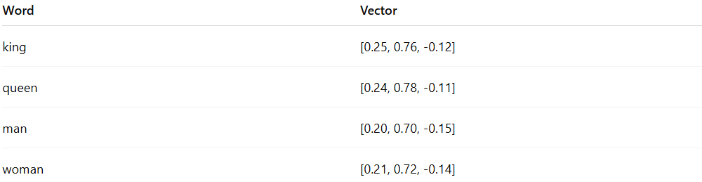
Word | Vector
king | [0.25, 0.76, -0.12]
queen | [0.24, 0.78, -0.11]
man | [0.20, 0.70, -0.15]
woman | [0.21, 0.72, -0.14]
- Semantic operations can be performed:
"king" - "man" + "woman" ≈ "queen"

Applications
# Source: AI Source: Provided by: [Data Path: Persons Table -> ID Column: 1, Name_En Column: Motasem Essam] -> From: [ChatGPT] on [12/10/2025]
- Sentiment analysis and text classification
- Machine translation and summarization
- Named entity recognition (NER)
- Semantic similarity and recommendation systems

Advantages
# Source: AI Source: Provided by: [Data Path: Persons Table -> ID Column: 1, Name_En Column: Motasem Essam] -> From: [ChatGPT] on [12/10/2025]
- Captures semantic meaning and relationships between words
- Efficient to train on large corpora
- Enables vector arithmetic for analogies

Disadvantages
# Source: AI Source: Provided by: [Data Path: Persons Table -> ID Column: 1, Name_En Column: Motasem Essam] -> From: [ChatGPT] on [12/10/2025]
- Fixed embeddings do not account for word context (same vector for “bank” in “river bank” vs “financial bank”)
- Requires large corpora for quality embeddings
- Sensitive to training parameters

